Low-Level Programming Languages

⚙️ What are Low-Level Programming Languages?
# Source: AI Source: Provided by: [Data Path: Persons Table -> ID Column: 1, Name_En Column: Motasem Essam] -> From: [Chatgpt (GPT‑5 Mini)] on [12/9/2025]
A low-level programming language is a type of programming language that is very close to the computer’s hardware and machine code.

📌 Simple definition:
# Source: AI Source: Provided by: [Data Path: Persons Table -> ID Column: 1, Name_En Column: Motasem Essam] -> From: [Chatgpt (GPT‑5 Mini)] on [12/9/2025]
Low-Level Language = Machine-friendly programming language

🧠 Key idea:
# Source: AI Source: Provided by: [Data Path: Persons Table -> ID Column: 1, Name_En Column: Motasem Essam] -> From: [Chatgpt (GPT‑5 Mini)] on [12/9/2025]
You write code that is very close to how the computer actually works (CPU, memory, registers).

🔍 Characteristics:
# Source: AI Source: Provided by: [Data Path: Persons Table -> ID Column: 1, Name_En Column: Motasem Essam] -> From: [Chatgpt (GPT‑5 Mini)] on [12/9/2025]
- ✅ Very fast execution
- ✅ Direct control over hardware
- ✅ Hard to read and write
- ✅ Not portable (depends on the machine)

🧩 Types of Low-Level Languages:

1. 🧮 Machine Language
# Source: AI Source: Provided by: [Data Path: Persons Table -> ID Column: 1, Name_En Column: Motasem Essam] -> From: [Chatgpt (GPT‑5 Mini)] on [12/9/2025]
- Written in binary (0s and 1s)
- Directly understood by the computer
Example:
10101000 11001010

2. ⚙️ Assembly Language
# Source: AI Source: Provided by: [Data Path: Persons Table -> ID Column: 1, Name_En Column: Motasem Essam] -> From: [Chatgpt (GPT‑5 Mini)] on [12/9/2025]
- Uses short codes (mnemonics) instead of binary
- Still very close to hardware
Example:
MOV A, 5
ADD A, 3

🆚 Low-Level vs High-Level
# Source: AI Source: Provided by: [Data Path: Persons Table -> ID Column: 1, Name_En Column: Motasem Essam] -> From: [Chatgpt (GPT‑5 Mini)] on [12/9/2025]
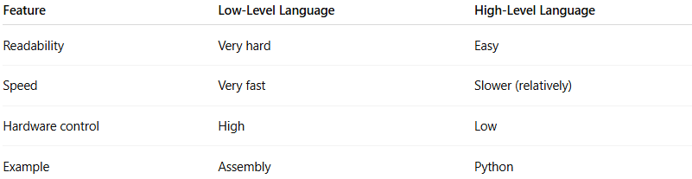
Feature | Low-Level Language | High-Level Language
Readability | Very hard | Easy
Speed | Very fast | Slower (relatively)
Hardware control | High | Low
Example | Assembly | Python

⚙️ When are they used?
# Source: AI Source: Provided by: [Data Path: Persons Table -> ID Column: 1, Name_En Column: Motasem Essam] -> From: [Chatgpt (GPT‑5 Mini)] on [12/9/2025]
- Operating systems 🖥️
- Embedded systems (devices, hardware) 🔌
- Performance-critical applications 🚀

✅ Summary:
# Source: AI Source: Provided by: [Data Path: Persons Table -> ID Column: 1, Name_En Column: Motasem Essam] -> From: [Chatgpt (GPT‑5 Mini)] on [12/9/2025]
Low-level languages give you maximum control and speed, but they are harder to use and understand.

